**NTC Virtual Classroom Tips and Instructions**

Thank you for enrolling in this BLM National Training Center (NTC) sponsored course. Please refer to the instructions below on connecting to the virtual classroom. If you have any questions or require additional assistance, please contact Peggy Deaton ([pdeaton@blm.gov](mailto:pdeaton@blm.gov)).

**Course Name:** Transitioning from ArcMap to ArcGIS Pro: Introduction to ArcGIS Pro 2.x

**Course Number:** BLM-TC-1730-71

**Course Dates:** May 25-27, 2021 9:00AM – 4:00PM Pacific Daylight Time

**Location:** Virtual Classroom

* [Teams site](https://teams.microsoft.com/l/team/19%3a4c40547133a5483dae5de70ec2d961ad%40thread.tacv2/conversations?groupId=0f68e1db-a1c9-4404-8c84-9b7068b8f4cc&tenantId=0693b5ba-4b18-4d7b-9341-f32f400a5494) – we will use this site for communication outside of class hours and for file sharing.
* [Zoom meeting](https://teams.microsoft.com/l/entity/com.microsoft.teamspace.tab.wiki/tab::c6e96d82-070c-4825-bccf-3d149209867b?context=%7B%22subEntityId%22%3A%22%7B%5C%22pageId%5C%22%3A3%2C%5C%22sectionId%5C%22%3A4%2C%5C%22origin%5C%22%3A2%7D%22%2C%22channelId%22%3A%2219%3A299d7227d13642d4908d7ac6abe90954%40thread.tacv2%22%7D&tenantId=0693b5ba-4b18-4d7b-9341-f32f400a5494) – we will use Zoom during class hours to present class materials and for discussion.

**Equipment:** A remote desktop connection will be made available for each student to complete the exercises and to connect to the necessary software. Please see the instructions below for connecting to the remote machine.

If you already have a local install of the software that you prefer to use, there are instructions below for this option as well.

**Software:** We will be using ArcGIS Pro 2.7 during this course, along with Microsoft Teams and Zoom for Government.

**Prework:** During the week prior to class, please [test your bandwidth speed](https://www.speedtest.net/). Plan to arrive to the first class 15-30 minutes early so that you can connect to the remote desktop (instructions below). Please confirm that you have completed your prework on the [spreadsheet](https://doimspp.sharepoint.com/sites/blm-NTC-Geospatial-Training-Courses-TransitioningfromArcMaptoArcGISPro/Shared%20Documents/Transitioning%20from%20ArcMap%20to%20ArcGIS%20Pro/1730-71%20Prework.xlsx) provided.

**Recommendations and tips:**

* Use two monitors during class if possible.
* Use a headset during class if available.
* Please join the Zoom meeting 15-30 minutes prior to class to ensure everything is working properly.
* Do not have other applications (i.e. Outlook, Chrome) open during class time.
* Minimize distractions during class time so you can focus on the course content.
* You have the ability to take yourself off mute during class to ask questions; if you are not speaking, please keep yourself on mute to minimize background noise.
* The chat function will allow you to chat with the entire class or with specific people only (including just the host and co-hosts).
* Ask questions!

**Instructions for connecting to the remote desktop (available 15-30 minutes before class begins):**

1. Ensure that you are connected to VPN using Pulse Secure.

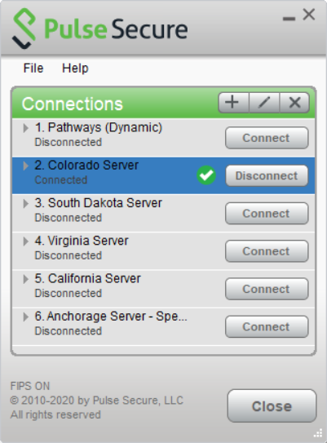

1. In the search bar at the bottom of your screen, type Remote Desktop Connection and select the app by that same name when it appears.

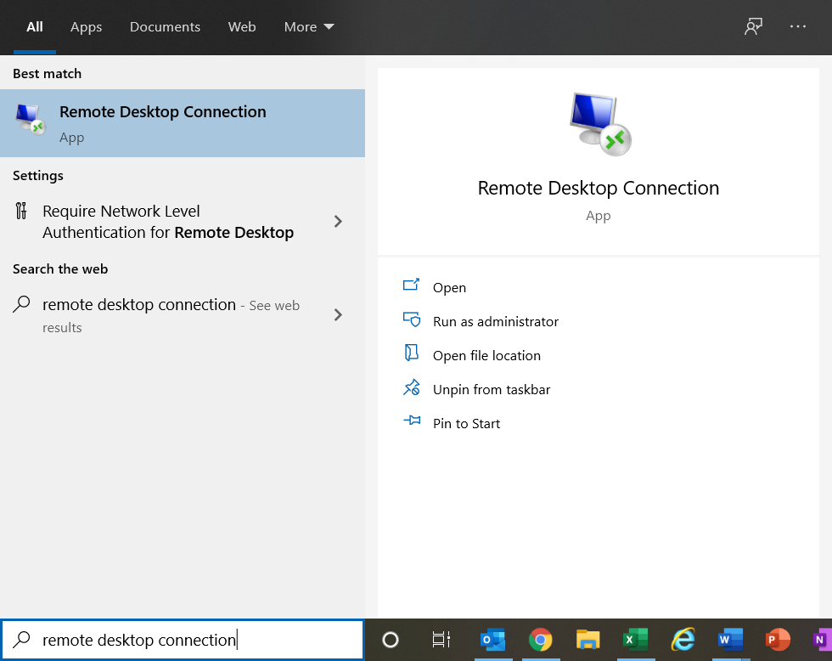

1. In the window that appears, type the computer number provided to you on the [prework spreadsheet](https://teams.microsoft.com/l/file/C0D00FC8-C2DD-40E3-B81F-DF60CE065044?tenantId=0693b5ba-4b18-4d7b-9341-f32f400a5494&fileType=xlsx&objectUrl=https%3A%2F%2Fdoimspp.sharepoint.com%2Fsites%2Fblm-NTC-Geospatial-Training-Courses-TransitioningfromArcMaptoArcGISPro%2FShared%20Documents%2FTransitioning%20from%20ArcMap%20to%20ArcGIS%20Pro%2F1730-71%20Prework.xlsx&baseUrl=https%3A%2F%2Fdoimspp.sharepoint.com%2Fsites%2Fblm-NTC-Geospatial-Training-Courses-TransitioningfromArcMaptoArcGISPro&serviceName=teams&threadId=19:299d7227d13642d4908d7ac6abe90954@thread.tacv2&groupId=0f68e1db-a1c9-4404-8c84-9b7068b8f4cc). Verify that your PIV card is inserted in your computer and click Connect.

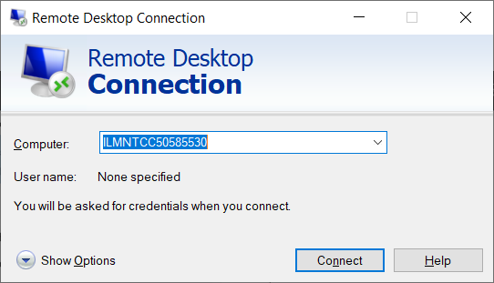

1. When prompted, enter the pin associated with your PIV card. If it doesn’t automatically default to the pin screen, click the option for “More Choices” and select the smartcard option.

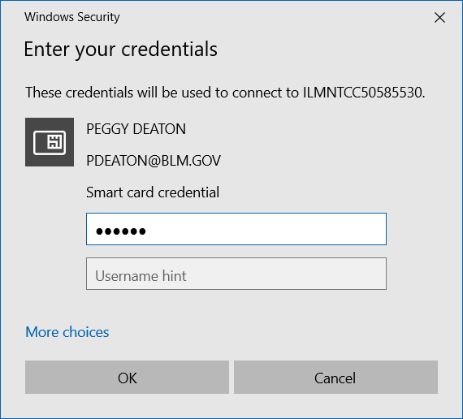

1. You should see the security screen once you are connected. Click the OK button to continue and it should bring you to the remote desktop. The first time you log in this may take a few minutes.

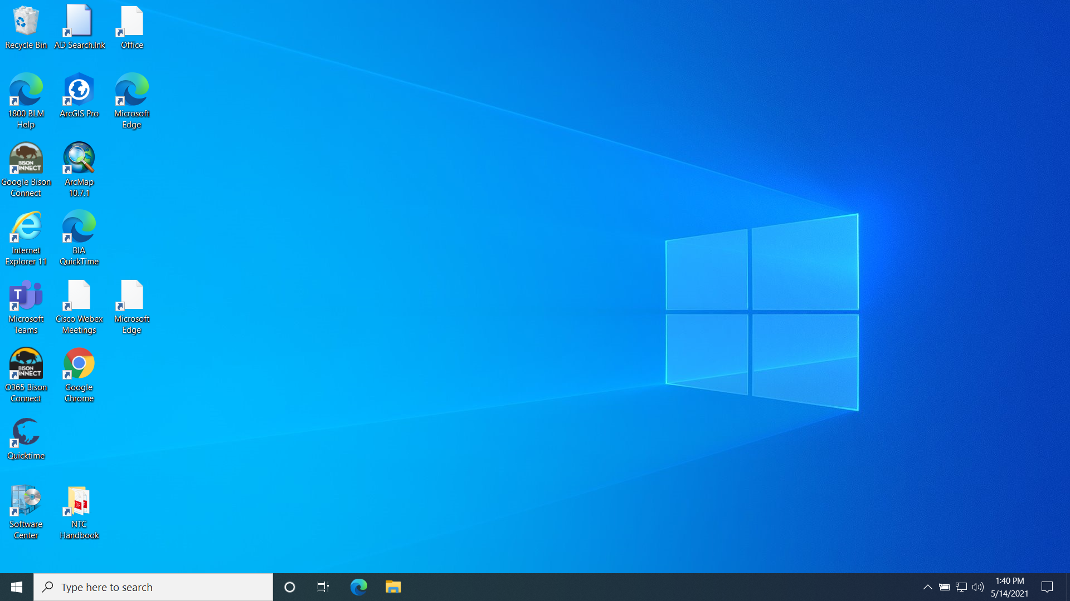

1. Your control bar is located at the top of your screen – use this to minimize or close your remote desktop connection. **PLEASE DO NOT USE THE SHUT DOWN BUTTON ON THE START MENU**.
2. You should now have access to all the necessary software for the class.

**If you are using a local install:**

1. Ensure that you are using the correct version of the software.
2. Download the class materials from the Teams site (Files 🡪 Class Data) and place it in your computer’s C:\tmp folder.

**Instructions for signing in to ArcGIS Pro:**

1. Double-click the ArcGIS Pro icon on your remote desktop connection.

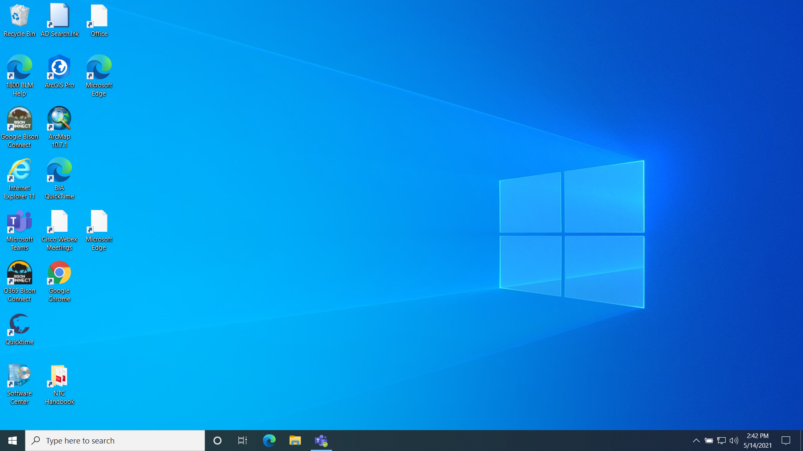

1. On the Sign In screen, click the option to use “Your ArcGIS Organization’s URL”. In the box provided, type blm-egis. Click Continue.

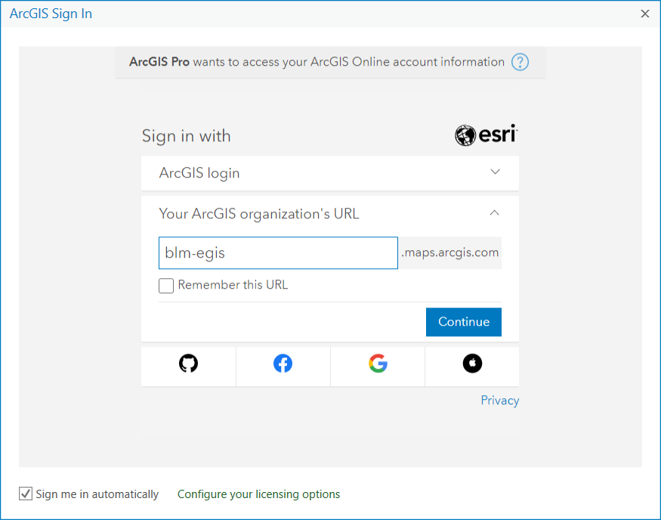

1. Select the option to sign in using your DOI Account.

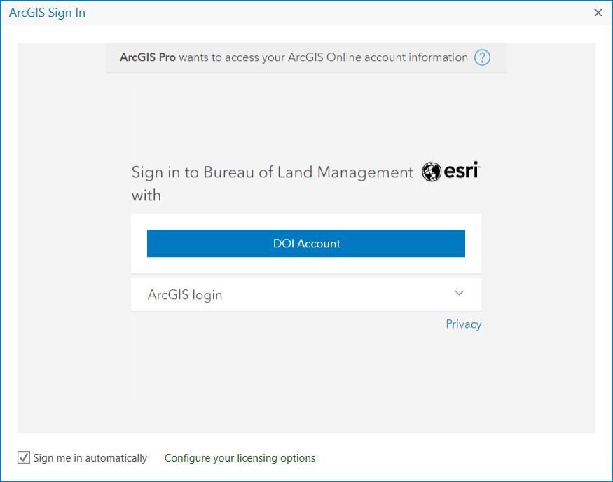

1. You are now signed in to ArcGIS Pro.

